

SC2006
Software Engineering

Team Members:
No | Name | Matriculation Number
 | CHIN WEI HAO | U2322704F
 | SU JING LONG, BRIAN | U2221634D
 | MURUGESAN NUVAAN | U2421726K
 | BIAN LINGZHU | U2422772F
 | Gupta Hitansh | U2423473J
 | YU ZHENGWEN | U2322264J

1. Introduction 3
1.1 Purpose 3
1.2 Data Dictionary 3
1.3 References 5
2. Overall Description 6
2.1 Product Perspective 6
2.2 Product Functions 6
2.3 User Classes and Characteristics 6
1. Primary User – Driver (General User) 6
2.4 Operating Environment 6
2.5 Design and Implementation Constraints 7
2.6 Assumptions and Dependencies 7
3. Functional Requirements 8
3.1. User Login 8
3.2. User Registration 8
3.3. Tabbed Navigation Buttons 8
3.4. Main View 8
4. Nonfunctional Requirements 10
4.1. Performance 10
4.2. Scalability 10
4.3. Security 10
4.4. Reliability 11
4.5. Usability 11
5. Use case diagram & description 11
5.1 Use case diagram 11
5.2 Use case description 12
6. UI Mockup 31
6.1 User login 31
6.2 User registration 32
6.3 Map 33
6.4 My Parking 34
6.5 Profile 36
7. Dialogue Map 38
8. Entity Class Diagram 39
9. Stereotype Class Diagram 39

1. Introduction

1.1 Purpose
The purpose of this Software Requirements Specification (SRS) is to provide a detailed description of the functional and non-functional requirements of CarParkSmart. This document serves as a reference for developers, testers, and project stakeholders to understand the intended behaviour and constraints of the system.
This SRS specifies the requirements for a mobile application that assists users in finding nearby car parks with the lowest parking rates, tracking parking charges, and managing parked vehicle locations. It also defines features that support parking reminders, family-based car location sharing, and navigation assistance.
The scope of this document is limited to the software components of the CarParkSmart application. External systems such as public car park data APIs, mapping services, and mobile operating system services are considered dependencies and are not specified in detail within this document.

1.2 Data Dictionary
Term | Definition
User | An individual who uses the CarParkSmart application.
Username | A unique customizable identifier for each User
Car | A car registered by a user for parking tracking purposes.
Car Name | A user defined name for a registered car
Carpark | A designated parking facility available to users.
Carpark Name | A name of the Carpark e.g. Blk 285
Carpark Location | The geographical coordinates of a car park.
Parking Rate | The cost charged for parking at a car park.
Parking Session | A period during which a vehicle is parked in a car park.
Parking Start Time | The time when a parking session begins.
Parking End Time | The time when a parking session ends.
Parking Session Driver | Driver who created the parking session
Estimated Fee | The estimated parking cost incurred by an active parking session
Accumulated Fee | The total parking cost incurred during a parking session.
Rate Alert | A notification triggered when parking fees exceed a user-defined limit.
Rate Alert Threshold | The maximum parking fee set by the user before an alert is issued.
Parked Car Location | The stored location of the vehicle after parking.
Car Location Update | A manual update of the parked vehicle’s location by the user.
Car Location Photo | An image reference to help users locate their parked vehicle.
Family Group | A group of users allowed to share parking location information.
Shared Access | Permission granted to family members to view the last parked location.
Navigation Assistance | Directions provided to guide users back to their parked vehicle.
Public Carpark API | An external data source that provides car park locations and rates.

1.3 References
Public Carpark API
  - Carpark availability: https://data.gov.sg/datasets/d_ca933a644e55d34fe21f28b8052fac63/view
  - Carpark rates:
  - https://data.gov.sg/datasets/d_9f6056bdb6b1dfba57f063593e4f34ae/view

2. Overall Description

2.1 Product Perspective
Singapore has a car owner rate of almost 40%. Many families and companies share cars and use it as their main mode of transport. Users often face challenges locating affordable parking, tracking and remembering their parking costs, as well as finding where the car was parked after finishing their activity. Existing navigation or car park finders do not adequately address these parking needs.

2.2 Product Functions
Locate nearby car parks and identify the cheapest available option based on parking rate data obtained from public APIs.
- Allow users to confirm when they have parked and initiate a parking session.
- Track parking duration and estimate parking charges using published car park rates.
  - Notify users when parking charges exceed a user-defined rate threshold.
- Allow users to manually record and update the parked car location.
  - Store photo references to assist users in locating their parked vehicle.
- Provide navigation guidance from the user’s current location to the parked car location.
- Enable family members to view the last known parked location of a shared vehicle.
- Manage parking history and display past parking records for registered vehicles.

2.3 User Classes and Characteristics

1. Primary User – Driver (General User)
- Uses the application regularly to locate nearby car parks and find the cheapest parking options.
- Can be working adult or student, with basic knowledge of technology usage
- Initiates and manages parking sessions by confirming when the vehicle is parked.
- Tracks parking rates and receives alerts when costs exceed predefined thresholds.
- Manually records and updates parked car locations.
- Uses navigation and photo references to locate the parked vehicle.
- Has basic technical proficiency with mobile applications.
Most functional requirements in this SRS are primarily designed to satisfy this user class.

2.4 Operating Environment
- The software will mainly be implemented in mobile platforms, mainly Android and iOS devices.
- For our demo, we will be focusing on creating a working prototype for Android phones.
- The application will require smartphones with standard mobile hardware components, including GPS, Internet Access, Touchscreen interface
- For features such as the fee alert, it will require being able to run as a background process

2.5 Design and Implementation Constraints
Due to limitations of a mobile device, we are unable to easily and reliably detect when a user has parked. As such, the system will require manual user input to indicate the start of a parking session.
- The application must comply with constraints imposed by the Android and iOS operating systems, including permissions for location access and background processing.
- The system is constrained by the capabilities and availability of external Public Carpark APIs, which provide parking rate and location data.

2.6 Assumptions and Dependencies
Public Carpark APIs provide accurate and reasonably up-to-date parking rate and location information.
- Users grant the necessary permissions (e.g. location access) required for the system to function correctly.
- The system will also depend on third-party map and navigation services and APIs for displaying maps and providing navigation assistance.

Functional Requirements

User Login
    - The system shall allow a user to log in to the application using Google OAuth 2 Authentication
    - The system will redirect user back to the app after logging into Google

User Registration
    - The system shall allow a user to create an account
      - The system will create a new user using Google OAuth 2 Authentication
        - The system will redirect user back to the app after logging into Google
        - The system will prompt the user to add a Username and profile picture during profile setup
          - The Username shall be longer than 5 characters
          - The Username shall not be longer than 30 characters
          - Adding a profile picture shall be optional

Tabbed Navigation Buttons
    - The system shall allow the user to switch between ‘Map’, ‘My Parking’ and ‘Profile’ Tabs

Main View
    - Map
      - The map shall show the user’s current location in the center upon loading
      - The map shall identify and display the nearby carparks available
        - Tapping the Carpark shall display the Parking Rate and Availability
        - The nearby carparks data shall be retrieved from the Public Carpark API
    - ‘Start Parking Session’ Action Button
      - The button shall allow the user to create a new parking session via pop up page
        - The page shall allow users to choose which car is assigned for this parking session
        - The page shall show the user their current parked location
          - The page should allow the user to edit their location precisely if necessary
        - The page shall display the Carpark details
          - The details shall include Parking Rate, Carpark Name and Location taken from public carpark API
        - The page shall allow the user to set session name and description
        - The page shall be able to add relevant pictures via a dialog
          - The dialog shall allow users to upload pictures from gallery
          - The dialog shall allow users to take a picture directly using their phone camera
        - The page shall allow the user to set a Rate Alert Threshold
          - The app shall trigger a Rate Alert by creating a notification when the Estimated Cost exceed the Threshold
        - The page shall contain a start parking button to start the session
          - The system shall provide default metadata for any session initiated without a user-defined name or description
      - The new parking session shall be viewable in My Parking Page
    - My Parking Page
      - The page shall show a list of cars registered under the user
        - Each entry shall be expandable to show the list of Parking Sessions based on the chosen car
      - List of Parking Sessions
        - The list of parking sessions shall show up to 3 most recent entries displayed in reverse chronological order.
        - Each entry shall show the Session Name, Carpark Name
        - Tapping the list entry shows the Parking Start Time, Parking End Time, Accumulated Fee or Estimated Cost, Session Driver, User-Uploaded Pictures and Carpark Location
          - The entry shall have stop session button if the session has not been ended
          - Tapping the Carpark Location shall redirect the user to their navigation app (eg: Google Maps) with the Carpark Location as destination
    - Profile Page
      - Personal Information
        - The system shall allow a user to view their profile information
          - The profile information shown shall include their Username, Google email and profile picture
        - The system shall allow a user to delete their account
      - Family Management
        - The system shall allow the user to create a family
          - Each account shall only be able to create 1 family
          - Each family created shall have a join code
        - The system shall allow the user to join a family using a join code
        - The system shall display the list of family members if the user is in a family
        - The system shall allow a user to generate a join code for the family group membership.
          - The family group membership shall have a limit 5
        - The system shall allow a user to remove other users from the family group membership
        - The system shall display all entries and cars registered under each individual user to all the members in the family group
      - Car Management
        - The system shall display the list of existing cars registered by the user
          - The details displayed shall include Carplate, Car Name, and a preset car icon.
        - The system shall allow a user to add a new car by clicking the add button
          - The button shall direct to the user to a pop up page
          - The User shall fill in the Carplate, Car Name and choose from a preset car icon
          - If any details are missing the system shall prompt the user with an error message that shows “not all required fields are filled in”.

Nonfunctional Requirements

Performance
    - The application must have a start up time of under 3 seconds
    - The main view map data should be loaded under 5 seconds upon successful login
    - The Carpark data should be loaded under 5 seconds upon selecting the Carpark
    - The Parking Session list shall be loaded and displayed under 3 seconds upon clicking on ‘My Parking’
    - The Parking Session data shall be loaded and displayed under 3 seconds upon clicking on the entry
    - After a parking session is created, it should be recorded into the backend system under 5 seconds
    - The system shall update parking fee calculations at intervals not exceeding 1 minute during an active parking session.
    - After joining a family via a join code, the system should add the user into the family and display all members under 10 seconds

Scalability
    - The application must handle up to 500 simultaneous users without a degradation in performance
    - The system shall maintain responses time within defined performance threshold when the number of active users increase

Security
    - Users of the application must be authenticated using secure OAuth2 Protocol
    - All sensitive information listed in 3.4.4 shall be encrypted.
    - All user data listed in 3.4.4 shall be deleted when their account is deleted
    - The system shall restrict shared parking data listed in 3.4.3 to authorized family group members only.
    - The system shall automatically log out users after 15 minutes of inactivity

Reliability
    - The application shall maintain a crash free session rate of at least 99% over a 30 day period
    - The system shall display a notification stating that “There is an error retrieving third party data” if external API data is unavailable
    - The system shall automatically retry failed API requests up to 5 attempts before displaying an error message.
    - The system shall maintain data consistency when network connectivity is temporarily lost and synchronize data once connectivity is restored.

Usability
    - Help messages must be displayed in the local language according to the user’s locale.
    - Users shall navigate between pages using the application's icons in under 3 seconds.

5. Use case diagram & description

5.1 Use case diagram
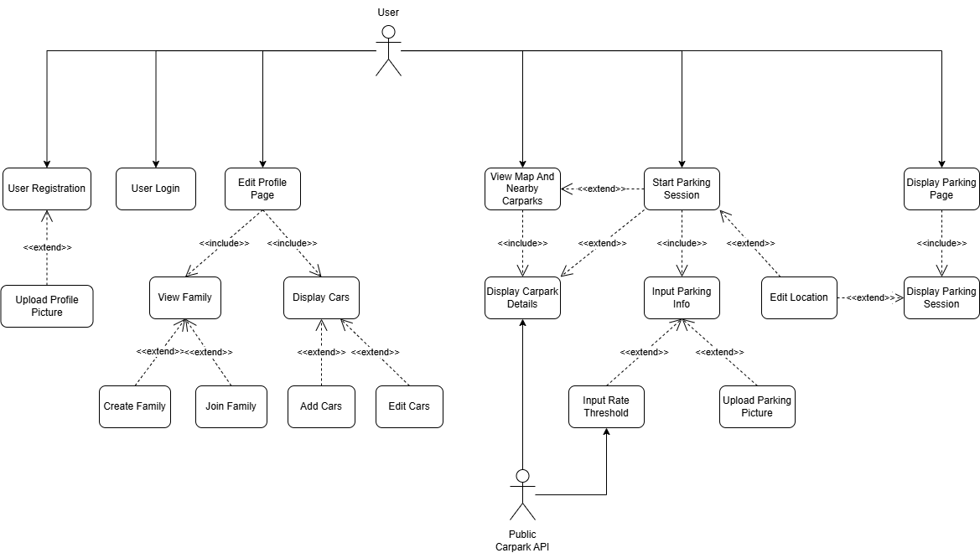

5.2 Use case description

Use Case ID: | 001
Use Case Name: | UserLogin
Created By: | Bian Lingzhu | Last Updated By: | Bian Lingzhu
Date Created: | 10/2/2026 | Date Last Updated: | 19/4/2026

Actor: | User
Description: | Allows a User to log into the application using GitHub or Magic Link authentication
Preconditions: | - User has a valid email or Github account  - User has registered before
Postconditions: | - User has logged in successfully  - User is redirected to the app
Priority: | High
Frequency of Use: | High
Flow of Events: | - If user wants to login with GitHub, user selects the “Sign in with GitHub” button  - If user wants to login with Magic Link, user selects the “Sign in with Magic Link” button  - Upon successful authentication, system retrieves matching user account based on email used  - User logs into their account and is directed to their most recent activity
Alternative Flows: | AF-S1: User logs in with Github  - System redirects user to GitHub authorization page  - User logs in to GitHub and grants permission to the application  - System redirects user to the application  AF-S2: User logs in with Magic Link  - User inputs an email to log in with  - System sends a log in link to the user’s email  - User clicks the log in link and is redirected to the application
Exceptions: | - If user cancels authentication, system redirects user back to login screen without logging in
Includes: | None
Special Requirements: | None
Assumptions: | None
Notes and Issues: | None
///////////////////////////////////////////////////////////////////////////////////////////////////////////////////////////////////////////////
Use Case ID: | 002
Use Case Name: | UserRegistration
Created By: | Bian Lingzhu | Last Updated By: | Bian Lingzhu
Date Created: | 10/2/2026 | Date Last Updated: | 19/4/2026

Actor: | User
Description: | Allows a user to create a new account using using GitHub or Magic Link authentication and complete profile setup
Preconditions: | - User has a valid GitHub or email account
Postconditions: | - User has registered a new account successfully  - User has setup their profile  - User is redirected back to the app
Priority: | High
Frequency of Use: | Low
Flow of Events: | - If user wants to login with GitHub, user selects the “Sign in with GitHub” button  - If user wants to login with Magic Link, user selects the “Sign in with Magic Link” button  - Upon successful authentication, system creates new user account  - System prompts user to enter a display name and profile picture  - User enters their display name and uploads a profile picture with use case UploadProfilePicture  - System validates username length  - System creates an account and directs user to the map tab
Alternative Flows: | AF-S1: User logs in with Github  - System redirects user to GitHub authorization page  - User logs in to GitHub and grants permission to the application  - System redirects user to the application  AF-S2: User logs in with Magic Link  - User inputs an email to log in with  - System sends a log in link to the user’s email  - User clicks the log in link and is redirected to the application
Exceptions: | - If any required information is not inputted, display an error message to notify user  - If username is too short (<5 characters), system displays a custom error message “Nickname must be at least 5 characters” and prompts re-entry.
Includes: | UploadProfilePicture
Special Requirements: | None
Assumptions: | None
Notes and Issues: | None

///////////////////////////////////////////////////////////////////////////////////////////////////////////////////////////////////////////////

Use Case ID: | 003
Use Case Name: | UploadProfilePicture
Created By: | Bian Lingzhu | Last Updated By: | Bian Lingzhu
Date Created: | 10/2/2026 | Date Last Updated: | 19/4/2026

Actor: | User
Description: | Allows a User to upload a picture
Preconditions: | - User is logged into the application
Postconditions: | - Picture is successfully uploaded  - User can continue with their registration
Priority: | Medium
Frequency of Use: | Medium
Flow of Events: | - System prompts user to upload a picture  - User can choose between take a picture from camera or upload from gallery  - System displays a preview of the profile picture and prompts for confirmation  - User presses confirms  - User returns to registering their account
Alternative Flows: | AF-S2.1: User chooses take a picture from camera  - Application will use the phone camera to take a picture  - Continue to step 3  AF-S2.2: User chooses chooses upload from gallery  - User can choose a past picture to upload from the phone’s photo gallery  - Continue to step 3  AF-S2.3: User chooses to not upload a profile picture  - A default icon will be inserted as the profile picture  - Continue to step 5
Exceptions: | - If camera/gallery permission denied, system displays permission request message “Enable camera/gallery permissions to upload picture”
Includes: | None
Special Requirements: | Enable access to camera and/or photo gallery
Assumptions: | None
Notes and Issues: | None

///////////////////////////////////////////////////////////////////////////////////////////////////////////////////////////////////////////////

Use Case ID: | 004
Use Case Name: | ViewMapAndNearbyCarparks
Created By: | Bian Lingzhu | Last Updated By: | Bian Lingzhu
Date Created: | 10/2/2026 | Date Last Updated: | 19/4/2026

Actor: | User
Description: | Displays the User’s current location and nearby carparks from the Public Carpark API.
Preconditions: | - User is logged in
Postconditions: | - Map and nearby carparks are displayed
Priority: | High
Frequency of Use: | High
Flow of Events: | - User uses navigation buttons to select the map tab  - System loads map centered on User’s current location  - System retrieves nearby carparks from Public Carpark API and displays all carparks nearby on the map  - System also displays a Nearest HDB Car Parks widget, with a list of hdb carparks nearby, and each carpark will have an orange arrow button beside it
Alternative Flows: | AF-S3.1: If user taps a Carpark, details of it are displayed with use case DisplayCarparkDetails  AF-S3.2: User can drag map around to observe nearby carparks, and press a recenter button to return to their current location  AF-S4: If user presses the orange arrow button, creates a new session, triggering the StartParkingSession use case
Exceptions: | - If location permission is denied, system displays permission request message “Enable location permissions to locate nearby carparks”  - If no nearby carparks are found, system displays a pop-up error message “No nearby carparks found” to inform user
Includes: | DisplayCarparkDetails  StartParkingSession
Special Requirements: | Location permission enabled  Nearby carparks retrieved from Public Carpark API
Assumptions: | None
Notes and Issues: | None
///////////////////////////////////////////////////////////////////////////////////////////////////////////////////////////////////////////////

Use Case ID: | 005
Use Case Name: | DisplayCarparkDetails
Created By: | Bian Lingzhu | Last Updated By: | Bian Lingzhu
Date Created: | 10/2/2026 | Date Last Updated: | 19/4/2026

Actor: | User
Description: | Displays all the information about a particular carpark
Preconditions: | - User is logged in
Postconditions: | - Carpark details are displayed
Priority: | High
Frequency of Use: | High
Flow of Events: | - User clicks into a carpark to see more details  - System retrieves data from Public Carpark API  - System will display the Carpark Name (address), Carpark no., Type, short-term parking information, lots availability and distance from user
Alternative Flows: | AF-S1: User can scroll to view all the information on the displayed page  AF-S3.1: User can press the cancel button to go back to the map tab  AF-S3.2: User can press the Park here button to trigger the StartParkingSession use case
Exceptions: | - If selected carpark data fails to load, system displays retry option
Includes: | StartParkingSession
Special Requirements: | None
Assumptions: | None
Notes and Issues: | None

///////////////////////////////////////////////////////////////////////////////////////////////////////////////////////////////////////////////

Use Case ID: | 006
Use Case Name: | StartParkingSession
Created By: | Bian Lingzhu | Last Updated By: | Bian Lingzhu
Date Created: | 10/2/2026 | Date Last Updated: | 19/4/2026

Actor: | User
Description: | Allows the User to create a new parking session
Preconditions: | - User is logged in  - User has at least one car registered
Postconditions: | - A new parking session is created
Priority: | High
Frequency of Use: | High
Flow of Events: | - User selects selects a button that creates a new parking session  - System displays a New Session form  - System uses a default carpark location prefilled in the new session form  - User edits which carpark to start the session at  - System displays a list of nearby carparks for the user to choose from  - User selects which car to assign to this parking session  - User enters the relevant information about the parking session under use case InputParkingInfo  - System enables create session button if all required information are present  - User confirms session  - System checks for validity of input data covered by InputParkingInfo use case  - System creates parking session
Alternative Flows: | AF-S3.1: User selects Park Now button on the main map tab screen  - Default location is the nearest carpark  AF-S3.2: User selects Park Here button under the carpark details screen of a specific carpark, or selects the arrow button beside a specific carpark under Nearest HDB Car Parks widget  - Default location is the specific carpark selected  AF-S3.3: If user wants to edit which carpark to start the session at  - Trigger the EditLocation use case
Exceptions: | - If some required fields are not filled in, disable the create session button
Includes: | DisplayCarparkDetails  InputParkingInfo  EditLocation
Special Requirements: | Location permission enabled
Assumptions: | None
Notes and Issues: | None

///////////////////////////////////////////////////////////////////////////////////////////////////////////////////////////////////////////////

Use Case ID: | 007
Use Case Name: | InputParkingInfo
Created By: | Bian Lingzhu | Last Updated By: | Bian Lingzhu
Date Created: | 10/2/2026 | Date Last Updated: | 19/4/2026

Actor: | User
Description: | Allows the User to edit their parked location
Preconditions: | - User is logged in  - User is creating a parking session
Postconditions: | - Parking information has successfully been input
Priority: | High
Frequency of Use: | High
Flow of Events: | - New session form displays a session name and a session description text field  - User inputs session name and session description  - New session form displays an option to upload a parking picture  - User adds relevant parking pictures with use case UploadParkingPicture  - New session form displays a text box for user to input their preferred rate alert threshold  - User sets a rate alert threshold with use case InputRateThreshold
Alternative Flows: | None
Exceptions: | - If the user does not select a car, system disables the create parking session button  - If the user does not input a session name, system disables the create parking session button  - If user already has an ongoing parking session, system prevents creation or a new session by displaying a custom error message
Includes: | InputRateThreshold  UploadParkingPicture
Special Requirements: | None
Assumptions: | None
Notes and Issues: | None

///////////////////////////////////////////////////////////////////////////////////////////////////////////////////////////////////////////////

Use Case ID: | 008
Use Case Name: | InputRateThreshold
Created By: | Bian Lingzhu | Last Updated By: | Bian Lingzhu
Date Created: | 10/2/2026 | Date Last Updated: | 19/4/2026

Actor: | User
Description: | Allows user to input their rate alert threshold
Preconditions: | - User is logged in  - User is inputting parking information
Postconditions: | - Location of the parking spot has successfully been changed
Priority: | Low
Frequency of Use: | Medium
Flow of Events: | - User inputs their preferred rate alert threshold  - System displays the estimated time the rate alert will be triggered based on the parking rate of the carpark, which data is retrieved from Public Carpark API  - When User's application detects that the rate alert threshold has been reached, system will send out a notification to the user’s phone  - Notification will show the current estimated cost, as well as the user’s threshold
Alternative Flows: | AF-S1: User does not input any threshold  - System will not record any threshold, parking session is created as normal  - No notification will be sent to the user during this parking session
Exceptions: | - If rate threshold is not a positive decimal number, system displays an error message “Please input a valid input rate threshold”  - If notifications are denied, system displays permission request pop-up and redirects user to phone settings
Includes: | None
Special Requirements: | None
Assumptions: | Notifications are enabled
Notes and Issues: | None

///////////////////////////////////////////////////////////////////////////////////////////////////////////////////////////////////////////////

Use Case ID: | 009
Use Case Name: | UploadParkingPicture
Created By: | Bian Lingzhu | Last Updated By: | Bian Lingzhu
Date Created: | 10/2/2026 | Date Last Updated: | 19/4/2026

Actor: | User
Description: | Allows user to upload a picture of where they parked their car
Preconditions: | - User is logged in  - User is creating a parking session
Postconditions: | - Picture is successfully uploaded  - User can continue with creating their parking session
Priority: | Medium
Frequency of Use: | Medium
Flow of Events: | - System prompts user to upload a picture  - User can choose between take a picture from camera or upload from gallery  - System displays a preview of the parking picture and prompts for confirmation  - User presses confirm  - User returns to creating their parking session
Alternative Flows: | AF-S2.1: User chooses take a picture from camera  - Application will use the phone camera to take a picture  AF-S2.2: User chooses chooses upload from gallery  - User can choose a past picture to upload from the phone’s photo gallery  AF-S2.3: User chooses to not upload a parking picture  - No picture will be displayed and operations continue as normal
Exceptions: | - If camera/gallery permission denied, system displays permission request message “Enable camera/gallery permissions to upload picture”  - If uploaded file format not supported or image file is too large, system displays custom error message of upload failure: “File format not supported”
Includes: | None
Special Requirements: | None
Assumptions: | None
Notes and Issues: | None

///////////////////////////////////////////////////////////////////////////////////////////////////////////////////////////////////////////////

Use Case ID: | 010
Use Case Name: | DisplayParkingPage
Created By: | Bian Lingzhu | Last Updated By: | Bian Lingzhu
Date Created: | 10/2/2026 | Date Last Updated: | 19/4/2026

Actor: | User
Description: | Allows User to view all their cars, with each car showing a list of current and past parking sessions
Preconditions: | - User is logged in
Postconditions: | - All parking sessions are displayed
Priority: | High
Frequency of Use: | High
Flow of Events: | - User navigates to My Parking tab with navigation buttons  - System displays a list of their registered cars in the page  - Each car will show their car name, license number and availability  - Each car expands to show their recent parking sessions, showing session name and carpark name  - User can interact with each parking session with DisplayParkingSession use case
Alternative Flows: | None
Exceptions: | - If no registered cars are found, display an empty page  - If a car has no parking sessions created for it yet, display message “No parking sessions yet” after expanding the car
Includes: | DisplayParkingSession
Special Requirements: | None
Assumptions: | None
Notes and Issues: | None

///////////////////////////////////////////////////////////////////////////////////////////////////////////////////////////////////////////////

Use Case ID: | 011
Use Case Name: | DisplayParkingSession
Created By: | Bian Lingzhu | Last Updated By: | Bian Lingzhu
Date Created: | 10/2/2026 | Date Last Updated: | 19/4/2026

Actor: | User
Description: | Allows User to view all the details about a specific parking session
Preconditions: | - User is logged in
Postconditions: | - Details of one parking session is displayed
Priority: | High
Frequency of Use: | High
Flow of Events: | - User taps into a specific parking session  - System displays a session summary card at the top of the screen, showing session state (ongoing or completed), start time, driver, and car used for this session and accumulated fee  - Each entry will further show editable fields such as session name, location, description, rate threshold  - User can scroll to view all the information on the displayed page
Alternative Flows: | AF-S2: If session is completed  - System additionally displays end time of the parking session  AF-S3.1: If user wants to edit text fields (Session name, description, rate threshold)  - User presses the edit icon beside the field  - System displays a text box with original input  - User edits input and presses save to change the input  - User presses cancel to revert any changes  AF-S3.1: If user wants to edit location  - Trigger the EditLocation use case
Exceptions: | - If rate threshold is not a positive decimal number, system displays an error message “Please input a valid input rate threshold”
Includes: | EditLocation
Special Requirements: | None
Assumptions: | None
Notes and Issues: | None

///////////////////////////////////////////////////////////////////////////////////////////////////////////////////////////////////////////////

Use Case ID: | 012
Use Case Name: | EditProfilePage
Created By: | Bian Lingzhu | Last Updated By: | Bian Lingzhu
Date Created: | 10/2/2026 | Date Last Updated: | 19/4/2026

Actor: | User
Description: | Allows users to view and manage their profile, such as their personal information, family and cars.
Preconditions: | - User is logged in
Postconditions: | - Profile page is displayed
Priority: | High
Frequency of Use: | High
Flow of Events: | - User navigates to Profile tab  - System will display their profile information, including their Username, Google email and profile picture  - User can select the “Edit Profile” button, the “Logout” button, the “Cars” button, the “Family” button or the “Delete Account” button
Alternative Flows: | AF-S3.1: If user selects the “Edit Profile” button  - System displays a page with an editable textbox containing their current username, and their current profile picture  - User can click onto their username and profile picture to edit them, and choose to finalise the information  - User will confirm the information inputted with the “Save Changes” button  - System will save the information, showing a loading icon at the “Save Changes” button  - System will redirect user back to the Profile page  AF-S3.2: If user selects the “Cars” button, trigger the DisplayCars use case  AF-S3.3: If user selects the “Family” button, trigger the ViewFamily use case  AF-S3.4: If user selects the “Delete Account” button to delete their account  - System will prompt confirmation for deletion  - User must confirm deletion  - Account will be deleted  AF-S3.5: If user selects the “Logout” button, gets redirected to Login page
Exceptions: | - If profile data failed to load, display retry option  - If account deletion fails, displays an error message “Account deletion failed, please try again”  - If any information is not edited, save the information as its previous state
Includes: | DisplayCars  ViewFamily
Special Requirements: | None
Assumptions: | None
Notes and Issues: | None

///////////////////////////////////////////////////////////////////////////////////////////////////////////////////////////////////////////////

Use Case ID: | 013
Use Case Name: | ViewFamily
Created By: | Bian Lingzhu | Last Updated By: | Bian Lingzhu
Date Created: | 10/2/2026 | Date Last Updated: | 19/4/2026

Actor: | User
Description: | Allows User to view who is in their family
Preconditions: | - User is logged in  - User is displaying their profile page
Postconditions: | - Able to view people in the family if user is in a family  - Able to continue to create or join a family if user is not currently in a family
Priority: | High
Frequency of Use: | Medium
Flow of Events: | - User taps on “Family” button  - If user is in a family, system will display the family management page, with a list of names of family members  - System will also display a join code at the top of the page
Alternative Flows: | AF-S2.1: User not in a family  - The family management page will display a message “You are not in a family”  - User can create or join a new family with the CreateFamily or JoinFamily use case  AF-S2.2: If user is the owner of the family, he can delete the family with the “delete family” button  - All members of the family will leave the family after family deletion  AF-S2.3: If user is a member of the family, he can leave the family with the “leave family” button  AF-S2.4: If user is the owner of the family, he can edit the family name  - User presses an edit icon besides current family name  - System displays a pop-up with a textbox for user to edit current family name  - User presses save button to confirm the current family name
Exceptions: | - If system fails to generate a unique join code, system displays a retry option
Includes: | CreateFamily  JoinFamily
Special Requirements: | None
Assumptions: | None
Notes and Issues: | None

///////////////////////////////////////////////////////////////////////////////////////////////////////////////////////////////////////////////

Use Case ID: | 014
Use Case Name: | CreateFamily
Created By: | Bian Lingzhu | Last Updated By: | Bian Lingzhu
Date Created: | 10/2/2026 | Date Last Updated: | 30/3/2026

Actor: | User
Description: | Allows User to create a new family or join an existing family
Preconditions: | - User is logged in  - User is displaying their family management page  - User is not in a family
Postconditions: | - Able to create a new family successfully
Priority: | High
Frequency of Use: | Low
Flow of Events: | - User taps on “Create family” button on the family management page  - System will create a new family, generating a join code for the family  - User will automatically join and become the owner of the new family
Alternative Flows: | None
Exceptions: | - If creation of family fails, display a custom error message “Failed to create new family, please try again”
Includes: | None
Special Requirements: | None
Assumptions: | None
Notes and Issues: | None

///////////////////////////////////////////////////////////////////////////////////////////////////////////////////////////////////////////////

Use Case ID: | 015
Use Case Name: | JoinFamily
Created By: | Bian Lingzhu | Last Updated By: | Bian Lingzhu
Date Created: | 10/2/2026 | Date Last Updated: | 30/3/2026

Actor: | User
Description: | Allows User to create a new family or join an existing family
Preconditions: | - User is logged in  - User is displaying their family management page  - User is not in a family
Postconditions: | - Able to join an existing family successfully
Priority: | High
Frequency of Use: | Low
Flow of Events: | - User taps on “Join family (Enter Code)” button on the family management page  - System will prompt user to enter a valid join code to join that family  - User enters a valid join code to join the family  - System registers user as a member of the family
Alternative Flows: | - None
Exceptions: | - If user enters invalid join code, system will notify the user with an error message “Invalid join code, please enter a new code”, prompting for a new join code  - If family already has 5 people, system will notify the user with an error message “Family is full, please enter a new code”, prompting for a new join code  - If any required information is not inputted, display an error message “Some required information is missing” to notify user
Includes: | None
Special Requirements: | None
Assumptions: | None
Notes and Issues: | None

///////////////////////////////////////////////////////////////////////////////////////////////////////////////////////////////////////////////

Use Case ID: | 016
Use Case Name: | DisplayCars
Created By: | Bian Lingzhu | Last Updated By: | Bian Lingzhu
Date Created: | 10/2/2026 | Date Last Updated: | 19/4/2026

Actor: | User
Description: | Allows user to view the cars that they or their family have registered
Preconditions: | - User is logged in  - User is displaying their profile page
Postconditions: | - All cars are displayed in a list
Priority: | High
Frequency of Use: | Medium
Flow of Events: | - User selects the “Cars” button  - System displays all registered cars by themselves and their family members  - Each car displayed will include Carplate, Car Name, and a preset car icon.  - User can select the “add car” button to add a new car, where the AddCar use case is triggered  - User can select the edit icon beside an existing car, where the EditCar use case is triggered
Alternative Flows: | None
Exceptions: | - If no cars are registered, display an empty state message  - If system failed to retrieve car list, display a retry option
Includes: | AddCar  EditCar
Special Requirements: | None
Assumptions: | None
Notes and Issues: | None

///////////////////////////////////////////////////////////////////////////////////////////////////////////////////////////////////////////////

Use Case ID: | 017
Use Case Name: | AddCars
Created By: | Bian Lingzhu | Last Updated By: | Bian Lingzhu
Date Created: | 10/2/2026 | Date Last Updated: | 19/4/2026

Actor: | User
Description: | Allows user to add a new car
Preconditions: | - User is logged in  - User is viewing their cars
Postconditions: | - Newly added cars are successfully displayed in the cars screen
Priority: | High
Frequency of Use: | Low
Flow of Events: | - User selects the “add car” button  - System directs user to a pop up page to input details about the car  - User inputs the Carplate, Car Name and choose from a preset car icon  - System prompts user to confirm the information  - User presses confirm to save the new car details
Alternative Flows: | None
Exceptions: | - If any required information is not inputted, display an error message “Some required information is missing” to notify user  - If the carplate number is in an invalid format, display an error message “Invalid carplate number, please enter a new carplate number  - If carplate already exists in the system, display an error message to inform user
Includes: | None
Special Requirements: | None
Assumptions: | A valid carplate number follows the format of Singapore’s Vehicle Registration Number (VRN)
Notes and Issues: | None

///////////////////////////////////////////////////////////////////////////////////////////////////////////////////////////////////////////////

Use Case ID: | 018
Use Case Name: | EditCars
Created By: | Bian Lingzhu | Last Updated By: | Bian Lingzhu
Date Created: | 10/2/2026 | Date Last Updated: | 19/4/2026

Actor: | User
Description: | Allows user to edit an existing car
Preconditions: | - User is logged in  - User is viewing their cars
Postconditions: | - Changes to edited cars are successfully displayed in the cars screen
Priority: | High
Frequency of Use: | Low
Flow of Events: | - User selects the edit pen icon beside a car  - System directs user to a pop up page to input details about the car  - User inputs a new Carplate, Car Name and choose from a preset car icon  - System prompts user to confirm the information  - User presses confirm to save the new car details
Alternative Flows: | None
Exceptions: | - If carplate name is <5 characters, display error message “Nickname must be at least 5 characters”  - If the carplate number is in an invalid format, display an error message “Enter a valid license plate e.g. SBA1234A”  - If carplate already exists in the system, display an error message to inform user
Includes: | None
Special Requirements: | None
Assumptions: | A valid carplate number follows the format of Singapore’s Vehicle Registration Number (VRN)
Notes and Issues: | None

///////////////////////////////////////////////////////////////////////////////////////////////////////////////////////////////////////////////

Use Case ID: | 019
Use Case Name: | EditLocation
Created By: | Bian Lingzhu | Last Updated By: | Bian Lingzhu
Date Created: | 10/2/2026 | Date Last Updated: | 19/4/2026

Actor: | User
Description: | Allows user to edit a chosen location for a parking session
Preconditions: | - User is logged in  - User has an active parking session
Postconditions: | - Changes location for the parking session is successful
Priority: | High
Frequency of Use: | Medium
Flow of Events: | - User presses the edit icon beside the location field  - System displays a change button  - User presses button  - System redirects user to a select carpark screen with an interface similar to map tab  - User selects a carpark and presses confirm and save to change the location
Alternative Flows: | None
Exceptions: | - If new location could not be saved, display an error message showing the specifics of the error and save the original location
Includes: | None
Special Requirements: | None
Assumptions: | A valid carplate number follows the format of Singapore’s Vehicle Registration Number (VRN)
Notes and Issues: | None

6. UI Mockup

6.1 User login
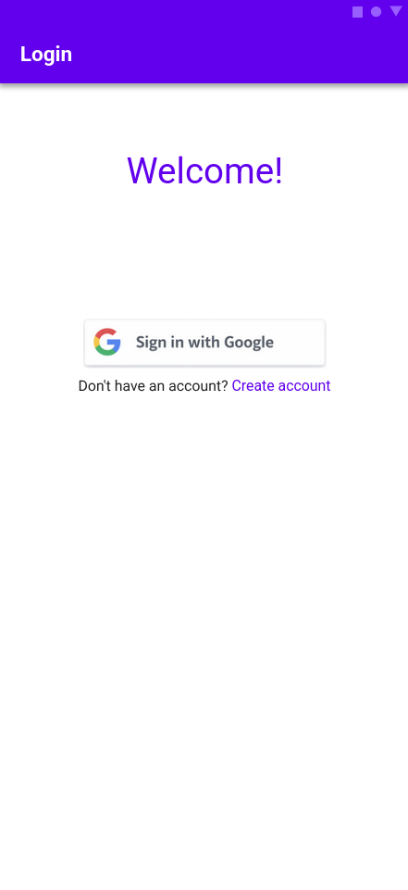

6.2 User registration
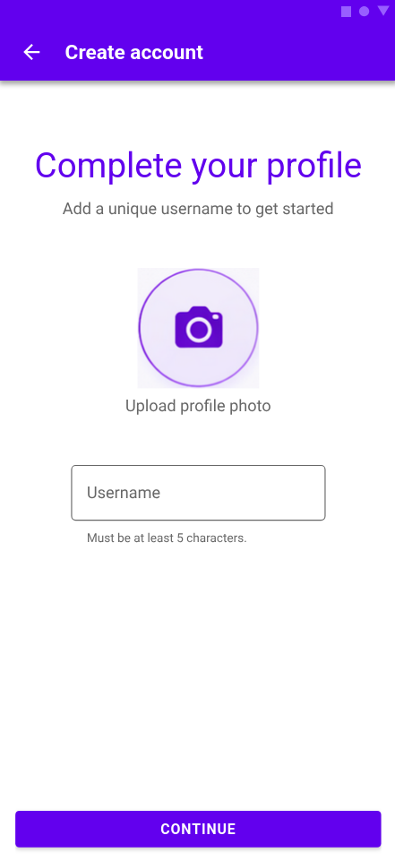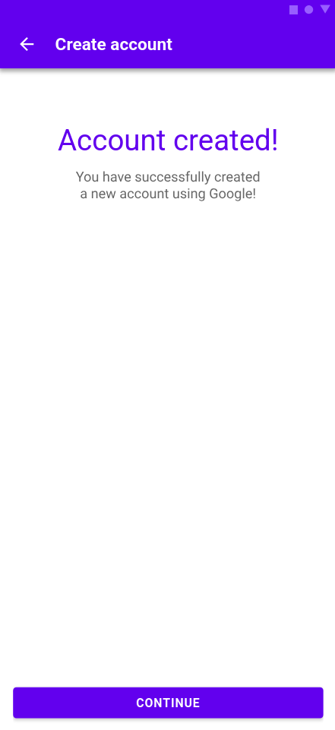

6.3 Map
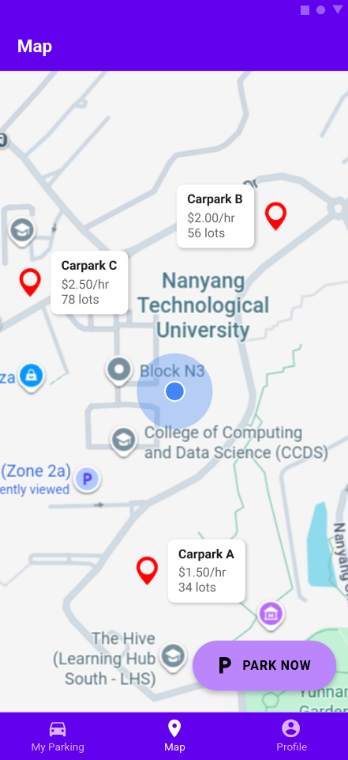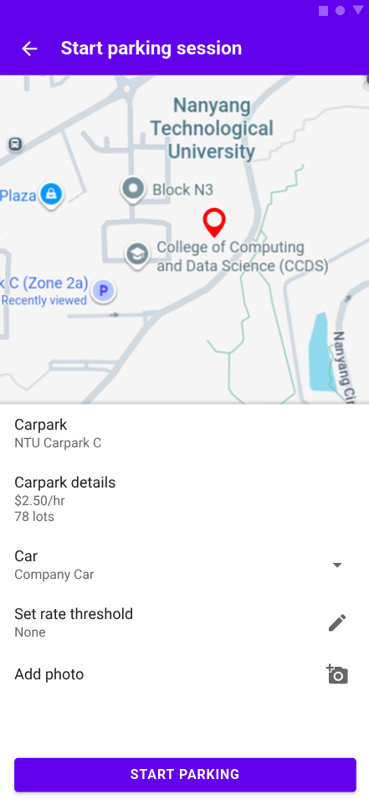

6.4 My Parking
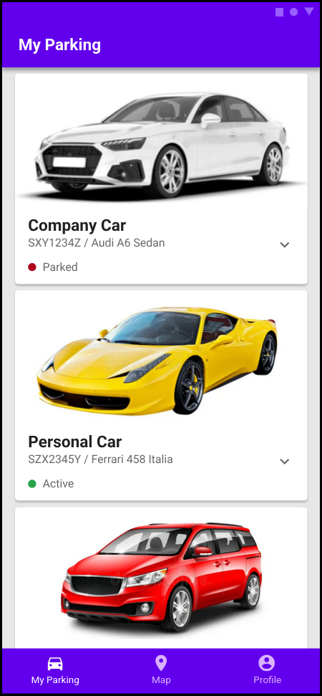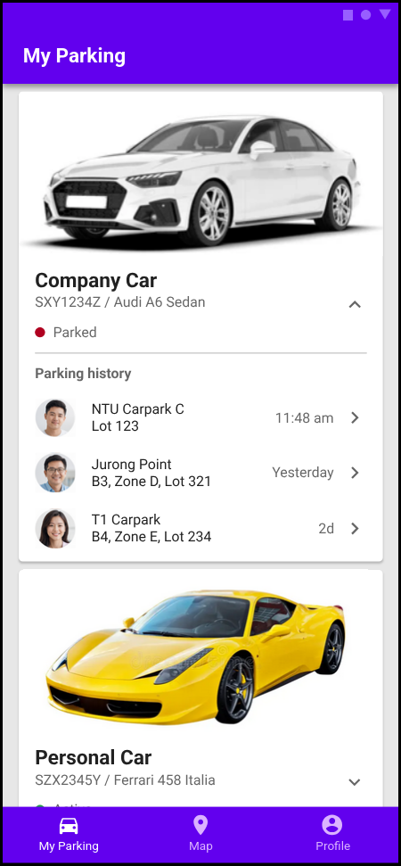
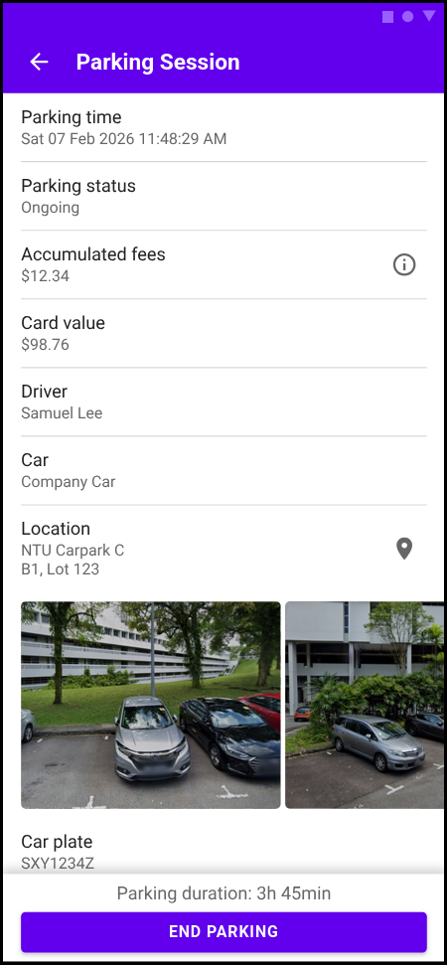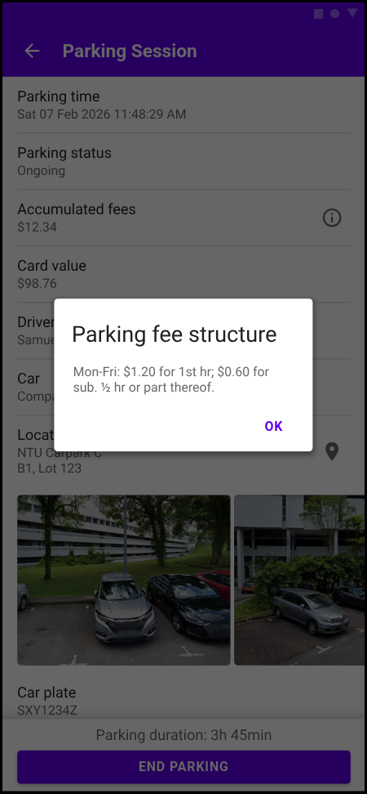

6.5 Profile
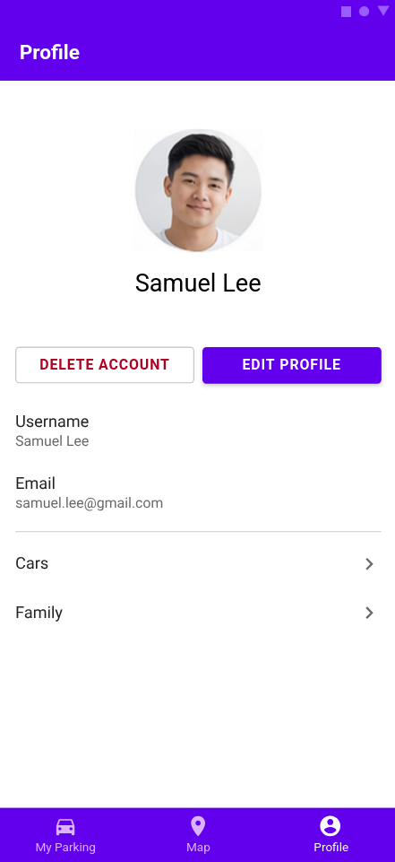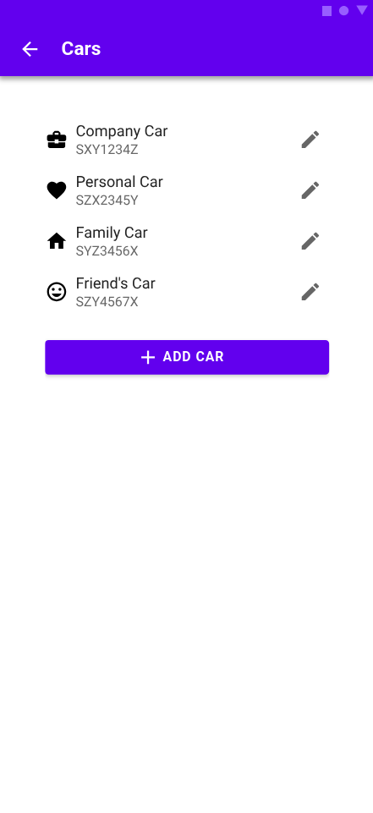
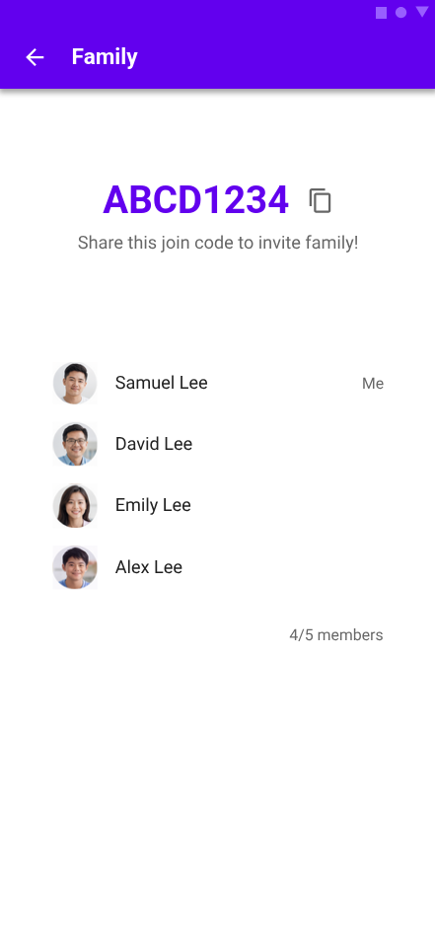

7. Dialogue Map
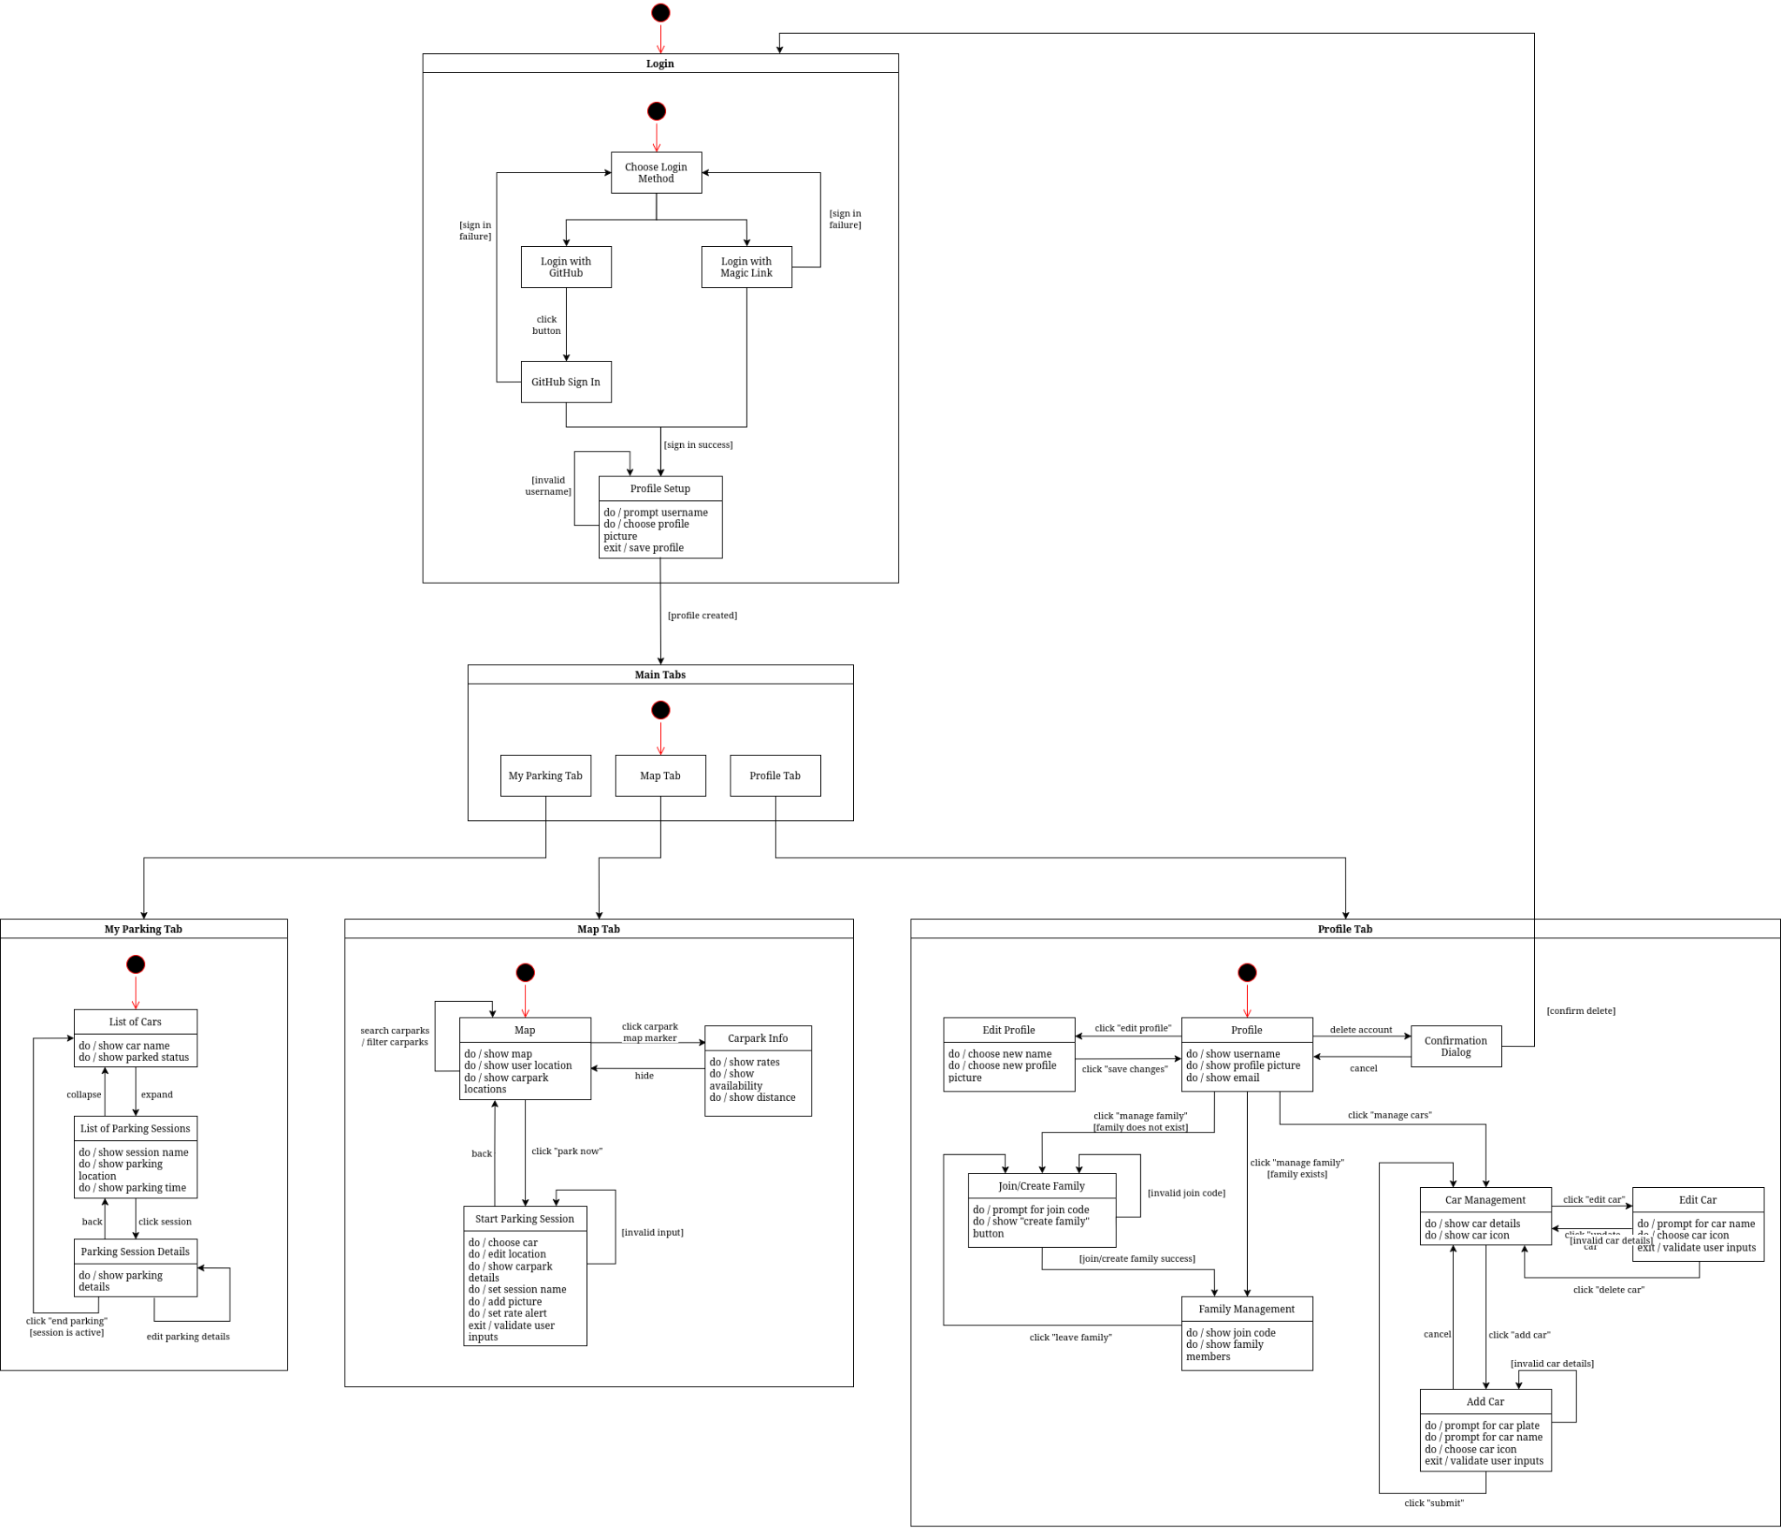

8. Entity Class Diagram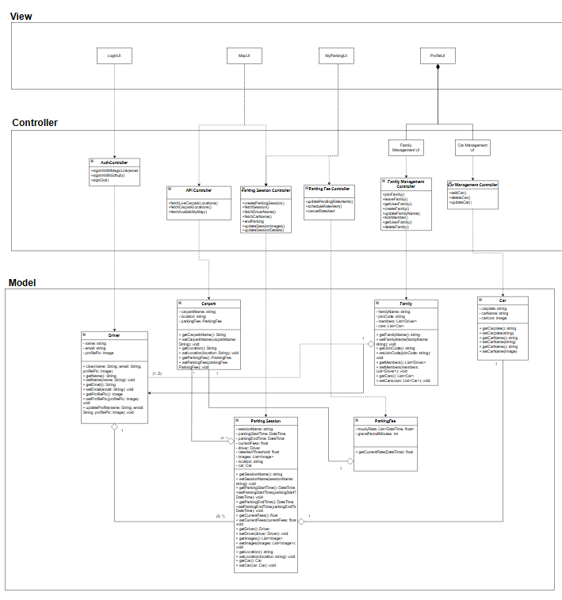

9. Stereotype Class Diagram

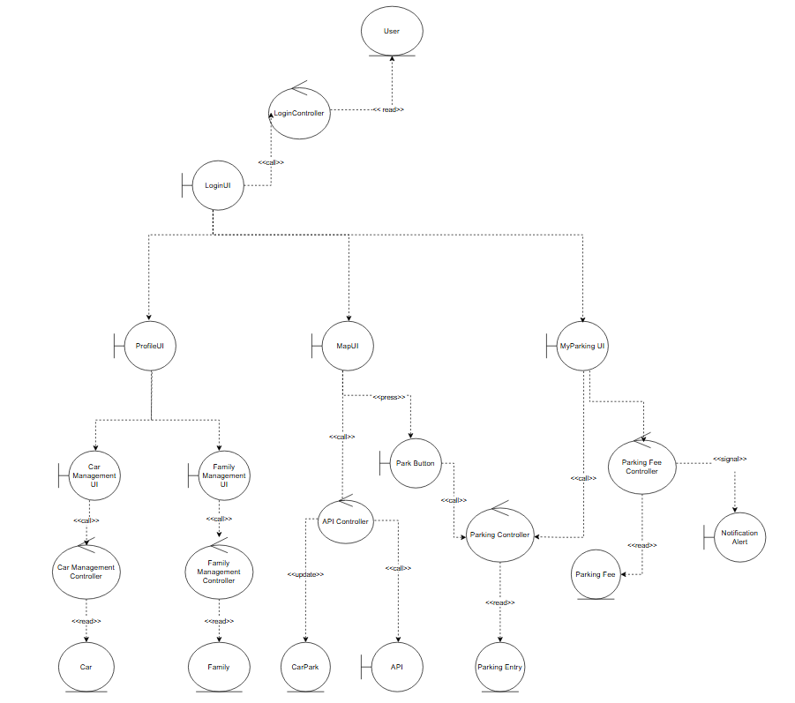

10 System Diagram
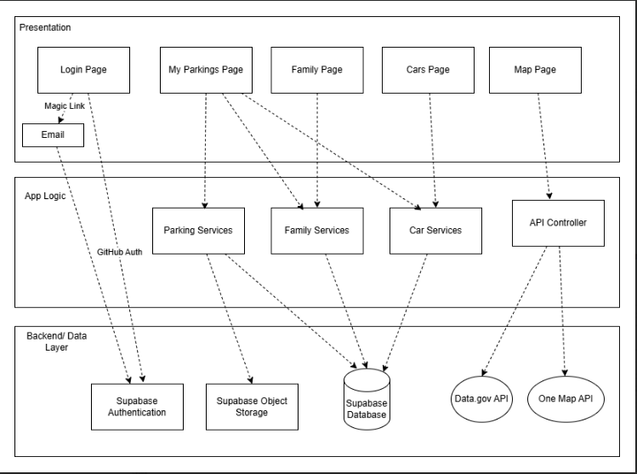

11. Black box testing

11.1 Start Parking Session
Being able to create a new parking session is a crucial component of our application, needing to process carpark data for users to choose and edit their desired carpark location, indicate the relevant car that they want to create a session for, as well as allowing users to be able to input a session name, an optional session description, rate threshold and optionally multiple photos.

Thus, when creating a new parking session, there are certain preconditions and input data restrictions that need to be adhered to. Thus, precondition and input data validation is implemented when creating a new parking session to ensure correctness and completeness. Firstly, equivalence classes are partitioned by splitting a set of all possible inputs into two or more smaller subsets, where inputs of the same subset share some trait in common: having the same behaviour, producing the same output or when one input produces a bug, others of the same subset would likely produce the same bug. For some test cases, boundary values are tested to check how the system behaves at the limits of acceptable input values

Black box testing was done manually on our application with corresponding inputs, and outputs were recorded as observed.

11.2 Equivalence class & boundary value testing
Here lists the valid equivalence classes for each input when starting a parking session, excluding the optional inputs where all inputs are valid and accepted, thus are expected to behave in the same way. This will be the basis of creating our black box test cases.

- Car Availability
Valid Equivalence Class | Invalid Equivalence Class
Has at least 1 car available before session creation | Has 0 cars available before session creation

- Carpark location chosen
Valid Equivalence Class | Invalid Equivalence Class
A carpark location has been chosen on the map | A carpark location has not been chosen

- Active session
Valid Equivalence Class | Invalid Equivalence Class
Has no active parking sessions | Has an active parking session

- Session Name Field
Valid Equivalence Class | Invalid Equivalence Class
Input has >= 1 character in the Session Name field | Input has 0 characters in the Session Name field

- Input Rate Threshold Field
Valid Equivalence Class (boundary) | Valid Equivalence Class | Invalid Equivalence Class | Invalid Equivalence Class
Input has 0 characters in the Input Rate Threshold field | Input is a non-negative numeric value in the Input Rate Threshold field | Input is non-numeric in the Input Rate Threshold field | Input is a negative numeric value in the Input Rate Threshold field

11.3 Test cases and Results
Test Case | Has >=1 Car | Carpark location is chosen | Active Session | Session Name Field | Input Rate Threshold Field | Expected Output | Actual Output
TC-01 | Yes (Valid) | Yes (Valid) | No (Valid) | “Lunch Parking” (Valid) | 3.50 (Valid) | Parking session successfully created | As expected, pass
TC-02 | No (Invalid) | Yes (Valid) | No (Valid) | “Lunch Parking” (Valid) | 3.50 (Valid) | "Create session" button is disabled. | As expected, pass
TC-03 | Yes (Valid) | No (Invalid) | No (Valid) | “Lunch Parking” (Valid) | 3.50 (Valid) | "Create session" button is disabled. | As expected, pass
TC-04 | Yes (Valid) | Yes (Valid) | Yes (Invalid) | “Lunch Parking” (Valid) | 3.50 (Valid) | Displays error message "Error: Could not create session." shown | As expected, pass
TC-05 | Yes (Valid) | Yes (Valid) | No (Valid) | "" (Invalid) | 3.50 (Valid) | "Create session" button is disabled. | As expected, pass
TC-06 | Yes (Valid) | Yes (Valid) | No (Valid) | “Lunch Parking” (Valid) | "abc" (Invalid) | Displays error message “Error: Input a positive numeric number for input threshold” | As expected, pass
TC-07 | Yes (Valid) | Yes (Valid) | No (Valid) | “Lunch Parking” (Valid) | -3.50 (Invalid) | Displays error message “Error: Input a positive numeric number for input threshold” | As expected, pass
TC-08 | Yes (Valid) | Yes (Valid) | No (Valid) | “Lunch Parking” (Valid) | "" (Valid, boundary) | Session created without rate alert | As expected, pass

12. White box testing

12.1 Calculate
The calculate method is used to calculate the accumulated parking fee of that parking session. As the carparks retrieved from the API are all HDB carparks, this calculation is based on short-term parking charges for HDB carparks, $0.60 per half-hour for carparks outside the central area of singapore, $1.20 per half-hour for carparks within Central Area during peak hours (7:00am to 5:00pm, Monday to Saturday), and $0.60 per half-hour for carparks within Central Area during non-peak hours.

The code for the calculate method in hdb_fee_calculator.dart was tested with white box testing methods, ensuring that the inputs lead to expected and accurate outputs. Test code in white_box_tc_hdbcalc.dart was written to assist with the process of testing the method, using mocked data objects to simulate specific entry times and carpark locations, which allowed for the immediate verification of pricing calculations without needing to wait for real-world time to elapse or being restricted by the 1-kilometer carpark proximity filter implemented in the application.

12.1.1 Control Flow Graph
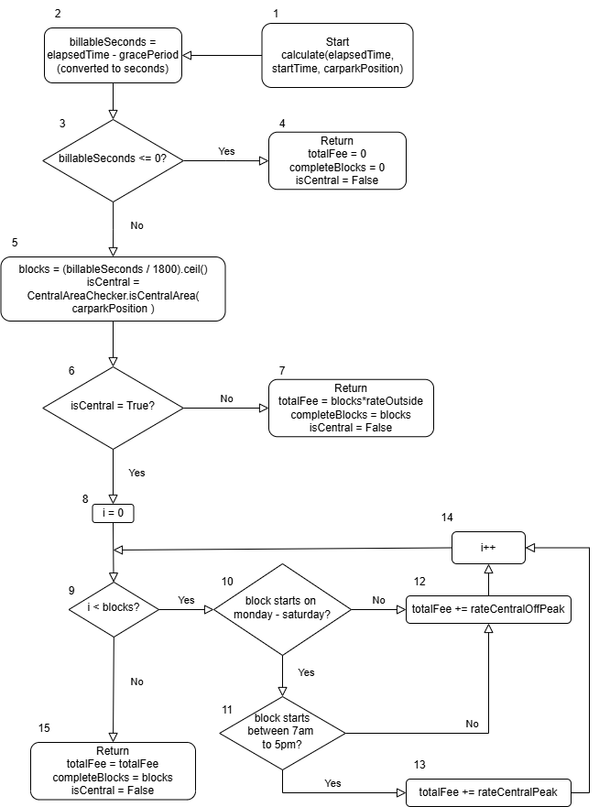

12.1.2 Basic Path Testing

Cyclomatic Complexity = | decision points | +1
= 5 + 1
= 6

Basis Paths
- Baseline path TC-01: 1, 2, 3, 5, 6, 8, 9, 10, 11, 14, 9, … 9, 15
- Basis Path TC-02: 1, 2, 3, 4
- Basis Path TC-03: 1, 2, 3, 5, 6, 7
- Basis Path TC-04: 1, 2, 3, 5, 6, 8, 9, 10, 12, 14, 9, … 9, 15
- Basis Path TC-05: 1, 2, 3, 5, 6, 8, 9, 10, 11, 12, 14, 9, … 9, 15
- Basis Path 06: 1, 2, 3, 5, 6, 8, 9, 15 (infeasible path)

Basis path 06 is an infeasible path since if we look at the logic, the requirements for the code to enter Basis path 06 is already covered by Basis Path TC-02. Thus, these two paths are mutually exclusive of each other, and the code will enter Basis Path TC-02 before ever reaching Basis Path 06.

Test Case | Description | Input | Expected result | Actual result
TC-01 | Parking in central area during peak hours, charge $1.20 per half-hour block | startTime: on a Monday, 10:00  elapsedTime: 60 minutes  carparkPosition: centralPosition | isCentral = True  completedBlocks = 2  totalFee = 2.40 | As expected, pass
TC-02 | Billable seconds <= 0, parking was within grace period, no fee charged | startTime: on a Monday, 10:00  elapsedTime: 10 minutes  carparkPosition: centralPosition | isCentral = False  completedBlocks = 0  totalFee = 0 | As expected, pass
TC-03 | Parking not in central area, charge $0.60 per half-hour block | startTime: on a Monday, 10:00  elapsedTime: 60 minutes  carparkPosition: nonCentralPosition | isCentral = False  completedBlocks = 2  totalFee = 1.20 | As expected, pass
TC-04 | Parking in central area not from Monday-Saturday, charge $0.60 per half-hour block | startTime: on a Sunday, 10:00  elapsedTime: 60 minutes  carparkPosition: centralPosition | isCentral = True  completedBlocks = 2  totalFee = 1.20 | As expected, pass
TC-05 | Parking in central area from Monday-Saturday but not between 7am-5pm, charge $0.60 per half-hour block | startTime: on a Monday, 20:00  elapsedTime: 60 minutes  carparkPosition: centralPosition | isCentral = True  completedBlocks = 2  totalFee = 1.20 | As expected, pass

12.2 Delete Family
The deleteFamily method is used to delete an existing family from the database. As the code tries calling the database in Supabase to delete the family with the corresponding joinCode, we check if the family was successfully deleted. In the case that an error is raised, we make sure to return an appropriate error message.

The code for the deleteFamily method in family_service.dart was tested with white box testing methods, ensuring that the inputs lead to expected and accurate outputs. Test code in white_box_tc_family.dart was written to assist with the process of testing the method, simulating the errors that are hard to trigger manually such as database connection failures, verifying that the service handles exceptions gracefully without crashing the application.

12.2.1 Control Flow Graph
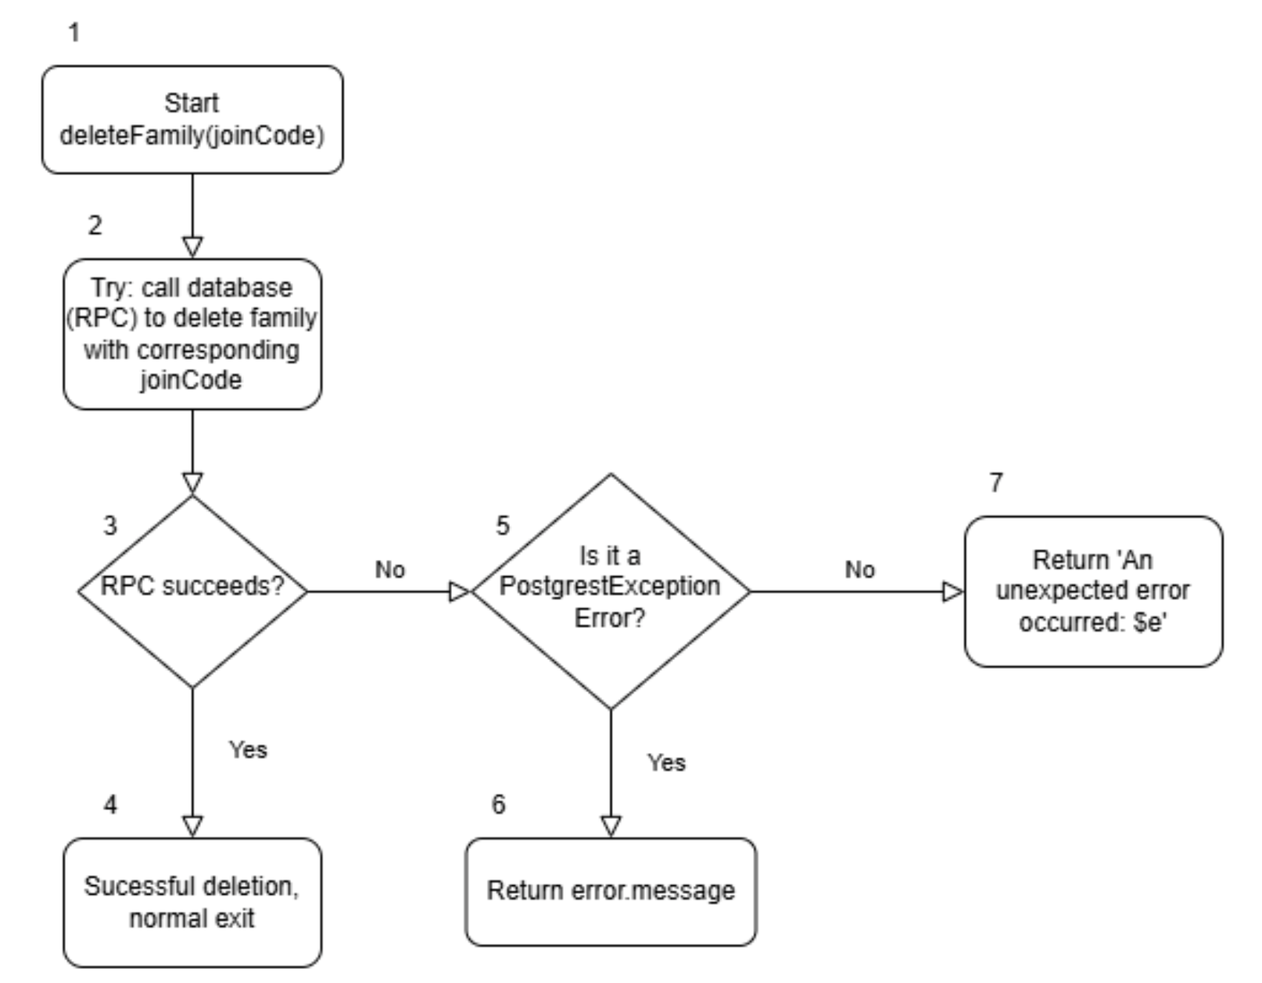

12.2.2 Basic Path Testing

Cyclomatic Complexity = | decision points | +1
= 2 + 1
= 3

Basis Paths
- Baseline path TC-01: 1, 2, 3, 4
- Basis Path TC-02: 1, 2, 3, 5, 6
- Basis Path TC-03: 1, 2, 3, 5, 7

Test Case | Description | Input | Expected result | Actual result
TC-01 | RPC completes without error and method returns successfully. | joinCode = "FAM-001"  mock RPC → returns null (success) | Method completes, no exception is thrown | As expected, pass
TC-02 | RPC throws a PostgrestException. The first catch block executes and rethrows only the .message string. | joinCode = "FAM-001"  mock RPC → throws PostgrestException(message: "foreign key violation") | Throws String = "foreign key violation" | As expected, pass
TC-03 | RPC throws a non-Postgrest exception (e.g. network error). The first catch does not match; the generic catch executes and rethrows with the "An unexpected error occurred:" prefix. | joinCode = "FAM-001"  mock RPC → throws Exception("network timeout") | Throws String starting with "An unexpected error occurred:" | As expected, pass

